Calculator instruction manual

This calculator mimics that of normal scientific calculator, it doesn't have all the functions available to most scientific calculators.

First of all, the calculator will ask you to type a number, when asked to enter a number, for example enter "5". You shouldn't enter anything in other than a number as the calculator will not be able to work correctly unless if told otherwise. Any length of numbers can be inputted.

After you have entered your first amount press enter to confirm, you will then be asked by the calculator to input your wanted operation. Again, press enter after typing the operation the way it has been displayed to you on the screen. If the following operations are desired: A number cubed, 10 to the power of a number, square root of a number, factorial of a number and the inverse of a number, it will only ask for one number instead of two, enter the number that you want to operate on before the operation.

For example: You want to do the factorial of 210.



1) Enter 210 with the Enter key.

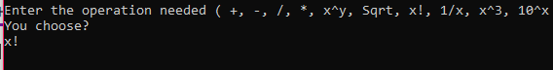

2) Enter "x! or X!" And press Enter to select the factorial operator.



3) Your answer will be printed  and you have the option to continue to use the calculator again or to exit. To exit to can press "E or e". The Console Application will close. If you choose to Continue the Application will loop back to the beginning and you will be able to reuse the Calculator.

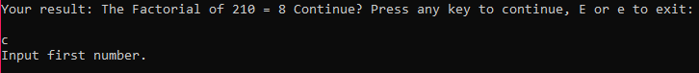

4)To Continue press any key other than "E or e" twice.